**Modern Wall Sculpture Decor Flower Abstract Metal Wall Art**

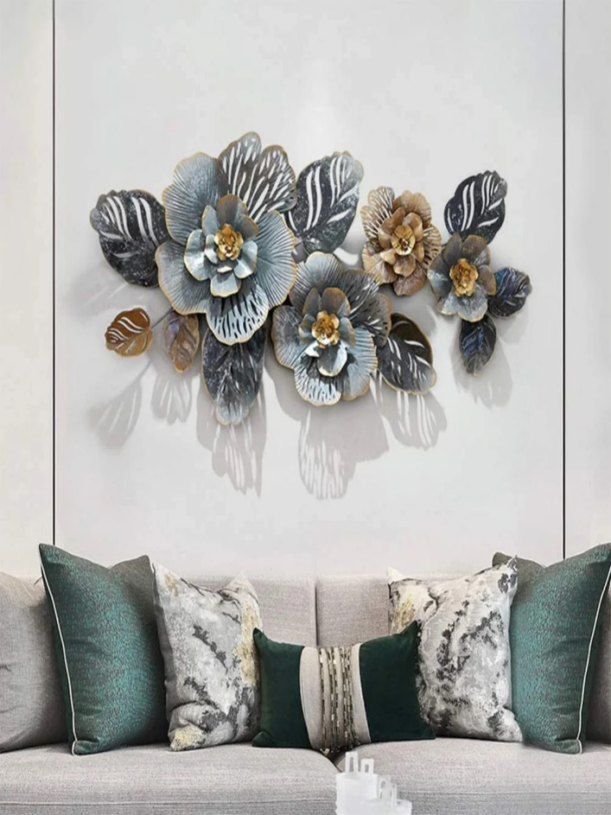Modern wall sculpture decor flower abstract metal wall art is a stunning, contemporary piece that transforms any space with its unique design and artistic flair. The sculpture typically features abstract representations of flowers, skillfully crafted from metal, with flowing, dynamic shapes and intricate textures that evoke movement and elegance. The use of metallic finishes, such as brushed silver, gold, or matte black, adds a sleek, sophisticated touch. Perfect for modern living rooms, offices, or galleries, this piece serves as a bold focal point that combines artistic expression with a sense of refined beauty, making it an eye-catching addition to any interior.